Name: Danny Jay M. Flores Course & Section: BSIT-3D

Jovie P. Senining

**IT 304 – Unit 2 Activity 1**

Web Output

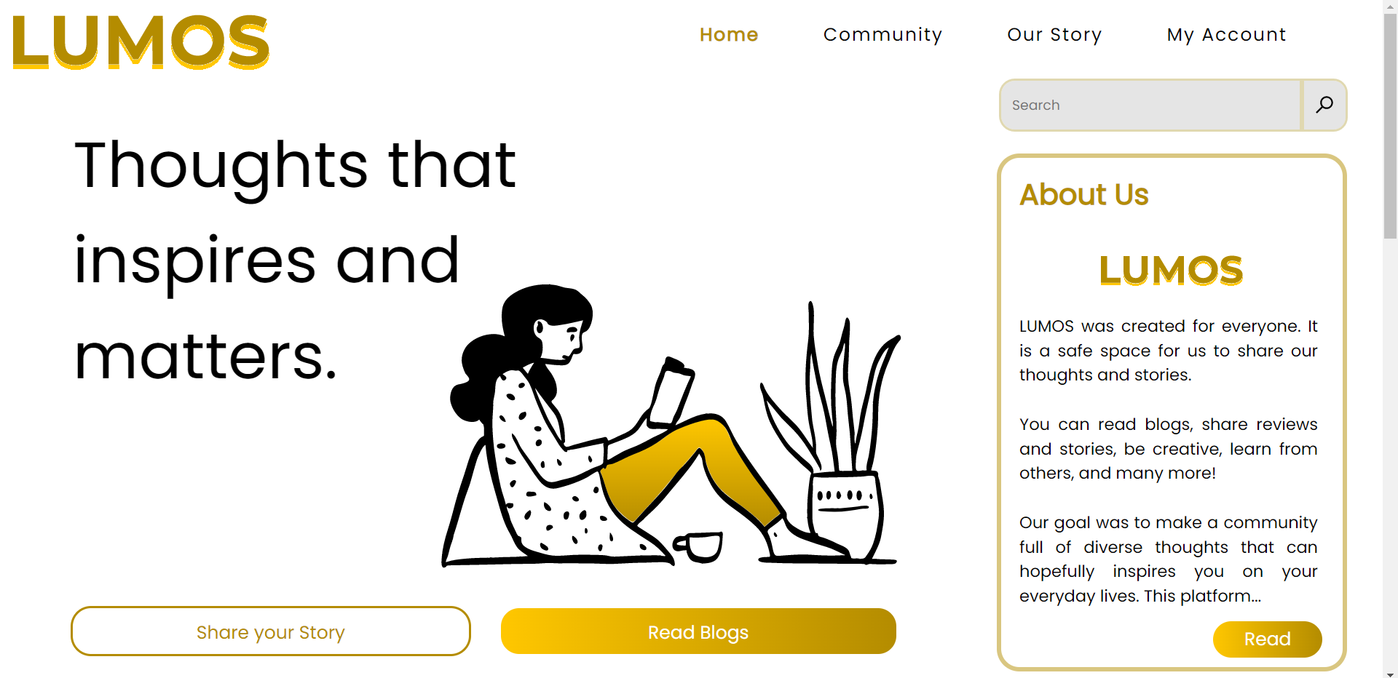

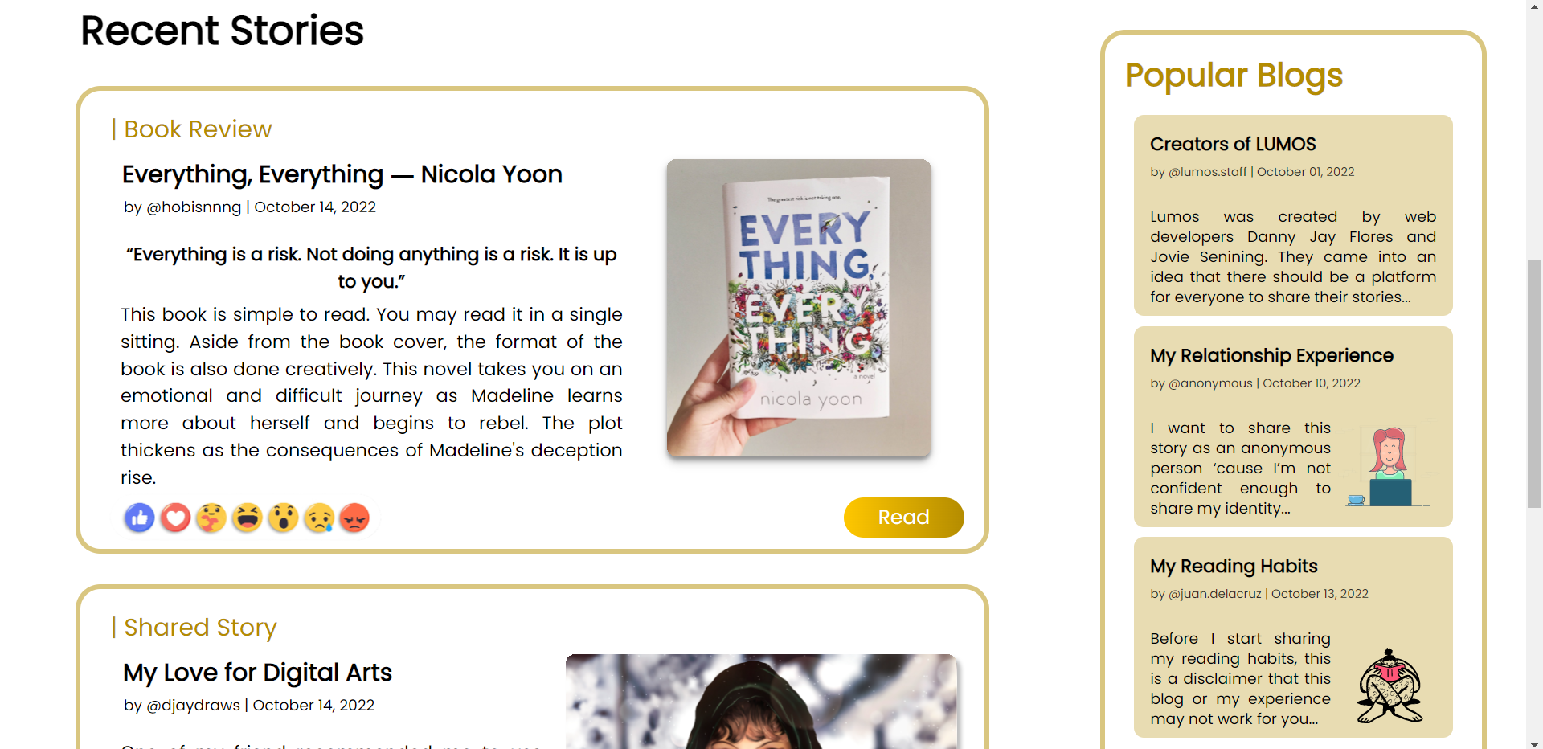

HTML Document

<!DOCTYPE html>

<html>

    <head>

        <link rel="preconnect" href="https://fonts.googleapis.com">

        <link rel="preconnect" href="https://fonts.gstatic.com" crossorigin>

        <link href="https://fonts.googleapis.com/css2?family=Poppins&display=swap" rel="stylesheet">

        <link rel="stylesheet" href="style.css">

        <title> Lumos - Home </title>

    </head>

    <body>

        <!--NAVIGATION-->

        <div class="topnav">

            <a href="blog.html" class="logo"><img src="images/LUMOS.svg" alt="lumos"></a>

            <nav>

                <ul>

                    <li><a href="#">My Account</a></li>

                    <li><a href="#">Our Story</a></li>

                    <li><a href="#">Community</a></li>

                    <li><a href="#" class="active">Home</a></li>

                </ul>

            </nav>

        </div>

        <!--LANDING-->

        <div class="landing">

            <p>Thoughts that inspires and matters.</p>

            <img class="landingbg" src="images/landingbg.svg" alt="">

            <button type="button" class="btn1">Share your Story</button>

            <button type="button" class="btn2">Read Blogs</button>

        </div>

        <!--SEARCH BAR-->

        <div class="searchbar">

            <input type="text" class="search-input" placeholder="Search">

            <button input="submit" class="srch-btn"></button>

        </div>

        <!--RIGHT PANEL-->

        <div class="rightpanel">

            <div class="about">

                <span class="aboutus">About Us<br><br></span>

                <img src="images/LUMOS.svg" alt=""><br>

                <span class="aboutdes">LUMOS was created for everyone. It is a safe space for us to share our thoughts and stories.

                <br><br>You can read blogs, share reviews and stories, be creative, learn from others, and many more!

                <br><br>Our goal was to make a community full of diverse thoughts that can hopefully inspires you on your everyday lives. This platform...</span>

                <button input="button" class="btn-read">Read</button>

            </div>

            <div class="popular">

                <span class="popularblogs">Popular Blogs</span>

                <div class="popular1">

                    <span class="title">Creators of LUMOS</span><br>

                    <span class="author">by @lumos.staff | October 01, 2022</span><br><br>

                    <span class="long">Lumos was created by web developers Danny Jay Flores and Jovie Senining. They came into an idea that there should be a platform for everyone to share their stories...</span>

                </div>

                <div class="popular2">

                    <span class="title">My Relationship Experience</span><br>

                    <span class="author">by @anonymous | October 10, 2022</span><br><br>

                    <span class="short">I want to share this story as an anonymous person ‘cause I’m not confident enough to share my identity...</span>

                    <img src="images/popimg1.svg" alt="">

                </div>

                <div class="popular3">

                    <span class="title">My Reading Habits</span><br>

                    <span class="author">by @juan.delacruz | October 13, 2022</span><br><br>

                    <span class="short">Before I start sharing my reading habits, this is a disclaimer that this blog or my experience may not work for you...</span>

                    <img src="images/popimg2.svg" alt="">

                </div>

                <button input="button" class="morebtn">More</button>

            </div>

            <div class="socials">

                <span class="follow">Follow Us</span>

                <a href="https://facebook.com" target="_blank"><img src="images/fb.svg" alt=""></a>

                <a href="https://instagram.com" target="_blank"><img src="images/ig.svg" alt=""></a>

                <a href="https://twitter.com" target="_blank"><img src="images/twitter.svg" alt=""></a>

            </div>

        </div>

        <!--ARTICLES-->

        <div class="article">

            <p>Recent Stories</p>

            <div class="blog1">

                <span class="categories">| Book Review</span>

                <h3>Everything, Everything ― Nicola Yoon</h3>

                <span class="user-info">by @hobisnnng | October 14, 2022</span>

                <span class="quote">“Everything is a risk. Not doing anything is a risk. It is up to you.”</span>

                <span class="description">This book is simple to read. You may read it in a single sitting.

                    Aside from the book cover, the format of the book is also done creatively.

                    This novel takes you on an emotional and difficult journey as Madeline learns more about herself and begins to rebel.

                    The plot thickens as the consequences of Madeline's deception rise.</span>

                <img class="reactions" src="images/reactions.svg" alt="">

                <img class="img1" src="images/blog1img1.svg" atl="">

                <button input="button" class="btn-read2">Read</button>

            </div>

            <div class="blog2">

                <span class="categories2">| Shared Story</span>

                <h3>My Love for Digital Arts</h3>

                <span class="user-info2"> by @djaydraws | October 14, 2022</span>

                <span class="description2">One of my friend recommended me to use this platform to share my story.

                    This community blog website is very helpful for us to share our thoughts,

                    and today I decided to share my experiences on how I started to draw and share my passion as an artist.

                <br><br>I started drawing digitally way back 2018. It is hard when I am just a beginner to digital drawing, cause I used to draw traditionally...</span>

                <img class="reactions2" src="images/reactions.svg" alt="">

                <img class="b2img1" src="images/blog2img1.svg" alt="">

                <img class="b2img2" src="images/blog2img2.svg" alt="">

                <img class="b2img3" src="images/blog2img3.svg" alt="">

                <img class="b2img4" src="images/blog2img4.svg" alt="">

                <button input="button" class="btn-read3">Read</button>

            </div>

        </div>

        <!--FOOTER-->

        <div class="footer">

            <footer>

                <p>For educational purposes only.</p><br>

                <p>by</p>

                <p><strong>Danny Jay M. Flores</strong></p>

                <p><strong>Jovie P. Senining</strong></p><br>

                <p>IT 304 - Unit 2 Activity 1 (BSIT-3D)

            </footer>

        </div>

    </body>

</html>

<!DOCTYPE html>

<html>

    <head>

        <link rel="preconnect" href="https://fonts.googleapis.com">

        <link rel="preconnect" href="https://fonts.gstatic.com" crossorigin>

        <link href="https://fonts.googleapis.com/css2?family=Poppins&display=swap" rel="stylesheet">

        <link rel="stylesheet" href="style.css">

        <title> Lumos - Home </title>

    </head>

    <body>

        <!--NAVIGATION-->

        <div class="topnav">

            <a href="blog.html" class="logo"><img src="images/LUMOS.svg" alt="lumos"></a>

            <nav>

                <ul>

                    <li><a href="#">My Account</a></li>

                    <li><a href="#">Our Story</a></li>

                    <li><a href="#">Community</a></li>

                    <li><a href="#" class="active">Home</a></li>

                </ul>

            </nav>

        </div>

        <!--LANDING-->

        <div class="landing">

            <p>Thoughts that inspires and matters.</p>

            <img class="landingbg" src="images/landingbg.svg" alt="">

            <button type="button" class="btn1">Share your Story</button>

            <button type="button" class="btn2">Read Blogs</button>

        </div>

        <!--SEARCH BAR-->

        <div class="searchbar">

            <input type="text" class="search-input" placeholder="Search">

            <button input="submit" class="srch-btn"></button>

        </div>

        <!--RIGHT PANEL-->

        <div class="rightpanel">

            <div class="about">

                <span class="aboutus">About Us<br><br></span>

                <img src="images/LUMOS.svg" alt=""><br>

                <span class="aboutdes">LUMOS was created for everyone. It is a safe space for us to share our thoughts and stories.

                <br><br>You can read blogs, share reviews and stories, be creative, learn from others, and many more!

                <br><br>Our goal was to make a community full of diverse thoughts that can hopefully inspires you on your everyday lives. This platform...</span>

                <button input="button" class="btn-read">Read</button>

            </div>

            <div class="popular">

                <span class="popularblogs">Popular Blogs</span>

                <div class="popular1">

                    <span class="title">Creators of LUMOS</span><br>

                    <span class="author">by @lumos.staff | October 01, 2022</span><br><br>

                    <span class="long">Lumos was created by web developers Danny Jay Flores and Jovie Senining. They came into an idea that there should be a platform for everyone to share their stories...</span>

                </div>

                <div class="popular2">

                    <span class="title">My Relationship Experience</span><br>

                    <span class="author">by @anonymous | October 10, 2022</span><br><br>

                    <span class="short">I want to share this story as an anonymous person ‘cause I’m not confident enough to share my identity...</span>

                    <img src="images/popimg1.svg" alt="">

                </div>

                <div class="popular3">

                    <span class="title">My Reading Habits</span><br>

                    <span class="author">by @juan.delacruz | October 13, 2022</span><br><br>

                    <span class="short">Before I start sharing my reading habits, this is a disclaimer that this blog or my experience may not work for you...</span>

                    <img src="images/popimg2.svg" alt="">

                </div>

                <button input="button" class="morebtn">More</button>

            </div>

            <div class="socials">

                <span class="follow">Follow Us</span>

                <a href="https://facebook.com" target="_blank"><img src="images/fb.svg" alt=""></a>

                <a href="https://instagram.com" target="_blank"><img src="images/ig.svg" alt=""></a>

                <a href="https://twitter.com" target="_blank"><img src="images/twitter.svg" alt=""></a>

            </div>

        </div>

        <!--ARTICLES-->

        <div class="article">

            <p>Recent Stories</p>

            <div class="blog1">

                <span class="categories">| Book Review</span>

                <h3>Everything, Everything ― Nicola Yoon</h3>

                <span class="user-info">by @hobisnnng | October 14, 2022</span>

                <span class="quote">“Everything is a risk. Not doing anything is a risk. It is up to you.”</span>

                <span class="description">This book is simple to read. You may read it in a single sitting.

                    Aside from the book cover, the format of the book is also done creatively.

                    This novel takes you on an emotional and difficult journey as Madeline learns more about herself and begins to rebel.

                    The plot thickens as the consequences of Madeline's deception rise.</span>

                <img class="reactions" src="images/reactions.svg" alt="">

                <img class="img1" src="images/blog1img1.svg" atl="">

                <button input="button" class="btn-read2">Read</button>

            </div>

            <div class="blog2">

                <span class="categories2">| Shared Story</span>

                <h3>My Love for Digital Arts</h3>

                <span class="user-info2"> by @djaydraws | October 14, 2022</span>

                <span class="description2">One of my friend recommended me to use this platform to share my story.

                    This community blog website is very helpful for us to share our thoughts,

                    and today I decided to share my experiences on how I started to draw and share my passion as an artist.

                <br><br>I started drawing digitally way back 2018. It is hard when I am just a beginner to digital drawing, cause I used to draw traditionally...</span>

                <img class="reactions2" src="images/reactions.svg" alt="">

                <img class="b2img1" src="images/blog2img1.svg" alt="">

                <img class="b2img2" src="images/blog2img2.svg" alt="">

                <img class="b2img3" src="images/blog2img3.svg" alt="">

                <img class="b2img4" src="images/blog2img4.svg" alt="">

                <button input="button" class="btn-read3">Read</button>

            </div>

        </div>

        <!--FOOTER-->

        <div class="footer">

            <footer>

                <p>For educational purposes only.</p><br>

                <p>by</p>

                <p><strong>Danny Jay M. Flores</strong></p>

                <p><strong>Jovie P. Senining</strong></p><br>

                <p>IT 304 - Unit 2 Activity 1 (BSIT-3D)

            </footer>

        </div>

    </body>

</html>

CSS file

* {

* {

    margin: 0;

    font-family: 'Poppins', sans-serif;

}

.topnav {

    position: relative;

    overflow: hidden;

}

.logo img {

    position: absolute;

    width: 282px;

    height: 86px;

    left: 14px;

    top: 5px;

}

.topnav a {

    float: right;

    color: black;

    text-align: right;

    padding: 25px 35px;

    text-decoration: none;

    font-size: 20px;

    letter-spacing: 1.5px;

}

ul {

    list-style-type: none;

    margin: 0;

    padding: 0;

}

.topnav a.active {

    color: #B48C00;

    font-weight: 600;

}

a:hover {

    color: #B48C00;

    font-weight: 600;

}

.search-input {

    position: absolute;

    left: 1100px;

    top: 90px;

    height: 30px;

    width: 304px;

    border: none;

    padding: 0.8em;

    border-radius: 1em 0em 0em 1em;

    background: #E5E5E5;

    font-size: 15px;

    font-family: 'Poppins', sans-serif;

    outline: solid #E0D8B0;

}

.search-input:focus {

    outline: solid #FFC700;

}

.srch-btn {

    position: absolute;

    left: 1433px;

    top: 90px;

    width: 45px;

    height: 53.7px;

    border: none;

    padding: 1em;

    border-radius: 0em 1em 1em 0em;

    background: #E5E5E5 url("images/search.svg") no-repeat right 0.8em center;

    outline: solid #E0D8B0;

    cursor: pointer;

}

.srch-btn:hover {

    outline: solid #FFC700;

    background: #FFC700 url("images/search.svg") no-repeat right 0.8em center;

}

.landing {

    position: absolute;

    width: 500px;

    height: 50px;

}

.landingbg {

    position: absolute;

    width: 505px;

    height: 379px;

    left: 485px;

    top: 200px;

}

.landing p {

    position: absolute;

    width: 501px;

    height: 314px;

    left: 80px;

    top: 50px;

    font-weight: 500;

    font-size: 70px;

    line-height: 105px;

    color: #000000;

}

.btn1, .btn2 {

    position: absolute;

    width: 435px;

    height: 50px;

    left: 80px;

    top: 590px;

    border: none;

    padding: 0.6em;

    background: #fff;

    border-radius: 1em;

    color:#B48C00;

    font-size: 20px;

    transition: background .3s;

    cursor: pointer;

    outline: solid #B48C00;

}

.btn2 {

    left: 550px;

    background: linear-gradient(90deg, #FFC700, #B48C00);

    border-radius: 1em;

    color:#fff;

    outline: none;

}

.rightpanel {

    position: absolute;

    left: 1100px;

    top: 175px;

}

.about, .popular {

    width: 335px;

    height: 520px;

    padding: 20px;

    border-radius: 20px;

    outline: solid #D9C680;

    outline-width: 5px;

}

.aboutus, .popularblogs {

    font-weight: 600;

    font-size: 32px;

    line-height: 40px;

    color: #B48C00;

}

.about img {

    display: block;

    margin: auto;

    width: 156px;

    height: 48px;

}

.aboutdes {

    position: absolute;

    margin-right: 1.5em;

    font-weight: 400;

    font-size: 18px;

    line-height: 27px;

    text-align: justify;

    color: #000000;

}

.btn-read {

    position: absolute;

    width: 120px;

    height: 40px;

    left: 233px;

    top: 510px;

    border: none;

    padding: 0.1em;

    background: linear-gradient(90deg, #FFC700, #B48C00);

    border-radius: 1em;

    color:#fff;

    font-size: 20px;

    transition: background .3s;

    cursor: pointer;

}

.popular {

    position: relative;

    top: 50px;

    height: 740px;

}

.popular1, .popular2, .popular3 {

    box-sizing: border-box;

    position: relative;

    display: block;

    margin: auto;

    padding: 1em;

    width: 317px;

    height: 200px;

    top: 20px;

    background: rgba(180, 140, 0, 0.3);

    border-radius: 10px;

    cursor: pointer;

}

.popular2 {

    top: 30px;

}

.popular3 {

    top: 40px;

}

.title {

    font-weight: 700;

    font-size: 18px;

    line-height: 27px;

    color: black;

}

.author {

    font-weight: 400;

    font-size: 12px;

    line-height: 15px;

    color: rgba(0, 0, 0, 0.8);

}

.long {

    position: absolute;

    width: 285px;

    font-weight: 500;

    font-size: 15px;

    line-height: 20px;

    text-align: justify;

}

.short {

    position: absolute;

    width: 180px;

    font-weight: 500;

    font-size: 15px;

    line-height: 20px;

    text-align: justify;

}

.popular2 img {

    position: absolute;

    left: 63%;

    top: 45%;

}

.popular3 img {

    position: absolute;

    left: 70%;

    top: 55%;

}

.morebtn {

    position: relative;

    left: 8px;

    top: 60px;

    width: 317px;

    height: 40px;

    border: none;

    padding: 0.1em;

    background: linear-gradient(90deg, #FFC700, #B48C00);

    border-radius: 1em;

    color:#fff;

    font-size: 20px;

    transition: background .3s;

    cursor: pointer;

}

.socials {

    position: absolute;

    display: block;

    margin: auto;

    width: 375px;

    height: 240px;

    top: 1400px;

    padding-top: 1em;

}

.socials img {

    width: 50px;

    display: block;

    margin: auto;

    text-align: right;

    padding-top: 1em;

    cursor: pointer;

}

.follow {

    display: block;

    font-weight: 600;

    font-size: 32px;

    line-height: 40px;

    text-align: center;

    color: #B48C00;

}

.article p {

    position: absolute;

    width: 295px;

    height: 54px;

    left: 80px;

    top: 750px;

    font-weight: 600;

    font-size: 40px;

    line-height: 60px;

    color: black;

}

.blog1, .blog2 {

    position: relative;

    width: 900px;

    height: 456px;

    left: 80px;

    top: 760px;

    border: none;

    border-radius: 20px;

    outline: solid #D9C680;

    outline-width: 5px;

}

.categories, .user-info, .quote, .description {

    position: absolute;

    width: 209px;

    height: 36px;

    left: 30px;

    top: 20px;

    font-weight: 400;

    font-size: 24px;

    line-height: 36px;

    color: #B48C00;

}

.blog1 h3 {

    position: absolute;

    width: 472px;

    height: 36px;

    top: 65px;

    left: 25px;

    font-weight: bolder;

    font-size: 24px;

    text-align: center;

    line-height: 36px;

    color: black;

}

.user-info {

    width: 263px;

    height: 22px;

    left: 43px;

    top: 105px;

    font-weight: 400px;

    font-size: 15px;

    line-height: 22px;

    color: #000000;

}

.quote {

    width: 500px;

    height: 58px;

    left: 40px;

    top: 150px;

    font-weight: 600;

    font-size: 18px;

    line-height: 27px;

    text-align: center;

    color: #000000;

}

.description {

    width: 500px;

    height: 182px;

    left: 40px;

    top: 210px;

    font-weight: 400;

    font-size: 18px;

    line-height: 27px;

    text-align: justify;

    color: #000000;

}

.img1 {

    position: absolute;

    width: 270px;

    height: 310px;

    left: 580px;

    top: 65px;

    filter: drop-shadow(0px 4px 4px rgba(0, 0, 0, 0.25));

    border-radius: 5px;

}

.reactions, .reactions2 {

    position: absolute;

    width: 319px;

    height: 55px;

    left: 5px;

    top: 400px;

}

.btn-read2, .btn-read3 {

    position: absolute;

    width: 120px;

    height: 40px;

    left: 760px;

    top: 405px;

    border: none;

    padding: 0.1em;

    background: linear-gradient(90deg, #FFC700, #B48C00);

    border-radius: 1em;

    color:#fff;

    font-size: 20px;

    transition: background .3s;

    cursor: pointer;

}

.blog2 {

    height: 490px;

    top: 800px;

}

.categories2, .user-info2, .description2 {

    position: absolute;

    width: 209px;

    height: 36px;

    left: 30px;

    top: 20px;

    font-style: normal;

    font-weight: 400;

    font-size: 24px;

    line-height: 36px;

    color: #B48C00;

}

.blog2 h3 {

    position: absolute;

    width: 273px;

    height: 36px;

    top: 65px;

    left: 40px;

    font-style: normal;

    font-weight: 700;

    font-size: 24px;

    text-align: center;

    line-height: 36px;

    color: black;

}

.user-info2 {

    width: 263px;

    height: 22px;

    left: 43px;

    top: 105px;

    font-weight: 400px;

    font-size: 15px;

    line-height: 22px;

    color: #000000;

}

.description2 {

    width: 420px;

    height: 182px;

    left: 40px;

    top: 150px;

    font-weight: 400;

    font-size: 18px;

    line-height: 27px;

    text-align: justify;

    color: #000000;

}

.b2img1 {

    position: absolute;

    width: 403px;

    height: 227px;

    left: 480px;

    top: 65px;

}

.b2img2, .b2img3, .b2img4 {

    position: absolute;

    width: 118px;

    height: 118px;

    left: 480px;

    top: 300px;

}

.b2img3 {

    left: 623px;

}

.b2img4 {

    left: 765px;

}

.reactions2 {

    top: 435px;

}

.btn-read3 {

    top: 440px;

}

.btn1:hover {

    background: linear-gradient(90deg, #FFC700, #B48C00);

    color: #fff;

    outline: none;

}

.btn2:hover, .morebtn:hover, .btn-read:hover, .btn-read2:hover, .btn-read3:hover {

    background: #FFC700;

    color: black;

    outline: none;

}

.popular1:hover, .popular2:hover, .popular3:hover {

    background: white;

    outline: solid #B48C00;

}

.footer {

    position: absolute;

    bottom: 0;

    top: 1900px;

    width: 100%;

    height: 250px;

    padding-top: 3em;

    color: black;

    background-color: #D9C680;

    text-align: center;

    letter-spacing: 1.5px;

}